Cognitive Behaviourism
Name of the institution
Name of the student
Date

History of Learning
Introduction
Learning was defined by Lachman (1997) as a change in behaviour due to experience and practice. This definition has widely been accepted in the field of psychology regardless of some of its drawbacks like that the permanent change in behaviour may not necessarily occur. There is no universal agreement on what learning should be defined as but it was argued by De Houwer, Barnes-Holmes, and Moors (2013) that such non agreement cannot be taken as an excuse to abandon definitional issues in learning. Leaning has been a centre for study in the psychology field over the years as evidenced by numerous research publications. Theories have also been developed to explain learning. Harasim (2017) defined a theory as an explanation of how and why something occurs. Studies on observable behaviour, cognitive behaviourism, cognitive mapping and memory and learning have been some of the most important studies in learning psychology.
Observable behaviour and learning
Several researchers have studied behaviour as a function of learning. The key contributor was Skinner (1954) and other researchers like Laiard (1985) and Burns (1995) reviewed his work. Burns, as cited by Dunn (2002), observed that behaviour could be classified into two; the observable behaviour and the unobservable one, which is internal processes like thinking. The proposition was that behaviour is a result of its own consequences. The learner repeats behaviour, which receives positive reinforcement, and this brings about learning. Behaviour was also observed to be weakened by negative conditions experienced and the learner abstains from it. The observation here is that learning is a process and consequences either encourage or discourage a behaviour. The net effect is repetition or abstinence from a behaviour and that brings about learning. As quoted by Catania (1984), Skinner taught pigeons on how to guides missiles during World War II and this was a major breakthrough in creation of some forms of behaviour through differential reinforcement.
Cognitive behaviourism and learning
The underlying assumption in the cognitive behaviourism is that cognitions lead to or mediate behavioural change (Kalodner, 2011). Skinner (1954) and Burns (1995), who had earlier tried to understand behavioural change as a sign of learning, also studied the area. Grinder (1989) observed that cognitive behaviourism is more concerned with how individuals acquire, retain, recall and transform information. These steps are key ingredients in the learning process through cognitive behaviourism.
Cognitive mapping behaviour
This model was advanced by Sir Edwards Tolman, which looks into the way in which the mind of a person conceptualizes processes. The cognitive maps have been defined based on the utilization of the brain space and do not have strict rules to be applied. Psychologist Edward used the study of rodents, specifically the rat to establish their behaviour in the utilization of their network paths commonly referred as Mazes.

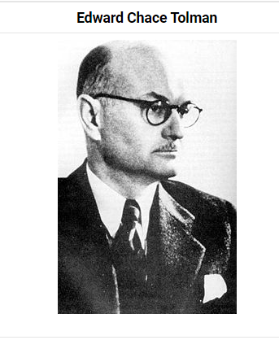
With Tolman study on the determinants of behaviour at choice point, three key factors were found to influence the behaviour which are the independent variable which are the stimuli, intervening variables like the appetite towards an action and dependent variable like the speed or number of error made.
In their paper in 1946, where Tolman, Ritchie and Kalish studied the behaviour of the rats to learn the maze established that the rats learned the maze freely without any reinforcement. After some trials with food placed at a certain point in the maze, the rats were in a position to learn to navigate to the point very quickly. The approach was characterized by its diversity in nature to be applicable in a variety of disciplines and the non-adherence to any rules, which meant no strict hierarchy of application. Later, the study by Buzan (1974) gave the concept a more straightforward look with the study of the mind mapping in human beings. The new look was on the key pillars of semantic networks and which represents knowledge. The study by Bennett (1996) on the existence of the cognitive maps in humans, rodents, birds and arthropods established the shortcoming of the cognitive maps based on the misleading definition and the possibility of shortcutting results emerged.
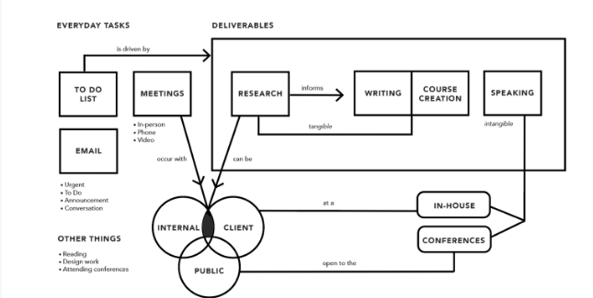
Source: Gibbons (2019)
Mind mapping
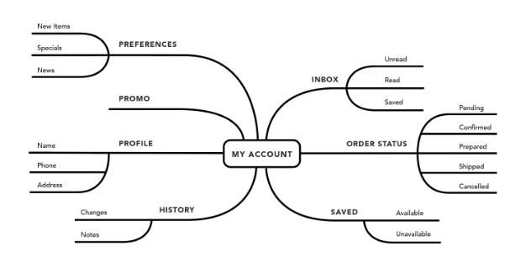
Source: Gibbons (2019)
Memory and Learning
According to the publication by Brandeis, Brandys and Yehuda (1989), in their study on the Morris water maze approach established that there is a close relationship between the two variables. While the learning process involves internalizing the personal experiences and the things individuals interact with, memory involves the ability to encode such information, storage of the information and retrieval of such information on a future date. As per Rumbaugh and Washburn (2003), reinforcement has not been a very material aspect of learning, as both reinforced and free learning did not constrain one another. The approach of learning indicates that learning will still take place provided individuals interact in a given set up or system.
On the other hand, the ability to memorize what is learned and more so among kids will be highly influenced by the level of the stimuli provided. Children will tend to gain more confidence in what they have learned when another person shares the same idea like their experience and this contributes to what they believe to be true (Nelson, 1993). According to Gabrieli (1998), the ability to memorize was influenced by more so the both internal factors like the health of the brain and age-related changes of an individual. The close relation requires one to have memory that can store what they learned and retrieve it in the future when required otherwise learning will be impossible.

References
Bennett, A. T. (1996). Do animals have cognitive maps?. Journal of Experimental
Biology, 199(1), 219-224.
Buzan, T. (1974). Use your head. Rajpal & Sons.
Brandeis, R., Brandys, Y., & Yehuda, S. (1989). The use of the Morris water maze in the study
of memory and learning. International Journal of Neuroscience, 48(1-2), 29-69.
Catania, A. C. (1984). The operant behaviorism of BF Skinner. Behavioral and Brain
Sciences, 7(4), 473-475.
De Houwer, J., Barnes-Holmes, D., & Moors, A. (2013). What is learning? On the nature and
merits of a functional definition of learning. Psychonomic bulletin & review, 20(4), 631-642.
Dunn, L. (2002). Theories of learning. Learning and teaching briefing papers series, 27.
Gabrieli, J. D. (1998). Cognitive neuroscience of human memory. Annual review of
psychology, 49(1), 87-115.
Grinder, R. E. (1989). Educational psychology: The master science. In An abbreviated version
of this paper was presented at the annual meeting of the American Psychological Association, Washington, DC, 1986.. Lawrence Erlbaum Associates, Inc.
Harasim, L. (2017). Learning theory and online technologies. Taylor & Francis.
Kalodner, C. R. (2011). Cognitive-behavioral theories. In D. Capuzzi & D. R. Gross
(Eds.), Counseling and psychotherapy (p. 193–213). American Counseling Association.
Lachman, S. J. (1997). Learning is a process: Toward an improved definition of learning. The
Journal of psychology, 131(5), 477-480.
Nelson, K. (1993). The psychological and social origins of autobiographical memory.
Psychological science, 4(1), 7-14.
Skinner, B. F. (1954). The science of learning and the art of teaching. Cambridge, Mass,
USA, 99, 113.
Tolman, E. C. (1952). Edward C. Tolman. A history of psychology in autobiography, 4, 323-
339.

